**Retail Concept**

|  |  |  |  |
| --- | --- | --- | --- |
| **Retail Name** | Village Shoe Store | | |
| **Retail Industry** | The industry that Village Shoe Store will fall under is a general merchandise retailer. Village Shoe store will be an upscale, high fashion retail store. We will offer high end brands and one on one consulting so that each customer can find the right fitting shoe. | | |
| **Retail Concept** | The retail concept that Village Shoe Store will fall under is a specialty store. Village Shoe Store will specialize in name brand shoes. We will also offer high end accessories like socks and shoe inserts. All employees will have a lot of knowledge of all the products we sell. | | |
| **Strengths** | **1** | Personal Service | Offering one on one customer service throughout the entire time a customer is in the store will be one of our greatest strengths. Giving the customer the time and attention, they need to make a decision and figure out what fits them best can set us ahead of the competition. I want all of our customers to feel like we care and value them. Having an employee there with the customer to go get shoes for them to try on and help advise them on how they fit will make Village Shoe Store the top shoe retailer in the area. |
| **2** | Risk Reduction | Being able to touch and see something in real life will help create risk reduction for our customers. Ordering something online, especially shoes, is a big gamble. You never know if they will actually fit, if you’ll like the colors, or if it will be comfortable or not. Being able to try on a shoe in the store before you purchase it eliminates that risk of the shoe not working out. Having a brick-and-mortar store will reduce the amount of returns we receive and will result in customers feeling confident about their purchases. |
| **3** | Immediate Gratification | Immediate gratification will be a strength for Village Shoe Store because customers can come in with a specific need for new shoes, socks, or inserts and have that need immediately fulfilled. Having a brick in mortar store makes it possible for people to just stop by and instantly fix that need. There is no waiting for something to be shipped to you like there is for online retailers. |
| **4** | Touch and Smell | When you purchase something online, the elements of touch and smell are taken from you. One of the many benefits of having a retail location is that consumers can actually touch and smell the products. Being able to see a product in person makes purchase decisions easier. The customers will know exactly what they are buying in the retail store because they can feel and try on the products. |
| **Weaknesses** | **1** | Channel Migration | Channel migration is a weakness of having a high-end retail location because customers can come in, try on the shoes, and gather all the information on them, then go and purchase the same product from a different retailer or channel. This is one of the weaknesses of a brick-and-mortar store because anyone is allowed to come in and try on shoes. However, there is no rule that the customer must buy those from you which can be a major weakness. This can also include showrooming, where the consumer gets all of the information from your store, but finds the product cheaper somewhere else and makes the purchase with that retailer. |
| **2** | Merchandise Assortment | A weakness of having a brick-and-mortar store compared to just an online store is that it is harder to have a deeper merchandise assortment in a retail store. Having more merchandise means having a larger store, more fixtures, and more employees which makes your expenses go up. It is easier for exclusive online retailers to have a deeper assortment because it does not add all the expenses like it does in a retail location. Having a narrower assortment than some online retailers is a weakness for Village Shoe Store. |
| **3** | Expenses | Maintaining a brick-and-mortar store can be very expensive. Rent, utilities, fixtures, and more employees are all added costs with having a physical retail location. All of these expenses add up quick and will lead to having less profit. Online retailers do not have all these added costs, which makes this a major weakness for brick-and-mortar stores. |
| **4** | Geographic Limitations | Because you have to choose a specific location for brick-and-mortar stores, it makes it harder to reach a larger number of customers. If there is not a physical location near the customer, you are missing out on their business. In an ideal world, every retailer would have locations that are accessible to everyone, but that is nearly impossible in today’s world, especially for a startup like Village Shoe Store. This is why choosing the best possible location for your store is so important to the success of your business. |
| **Opportunities** | **1** | Expanding to other channels | Establishing a strong retail presence is very important because it can lead to expanding your channels. Creating a website and participating in online retailing alongside your physical location can boost sales and increase the geographic limitations. Website’s can be accessed from any smartphone, tablet, or laptop which makes it so much easier for customers who do not live in the region of your store to still make purchases from you. |
| **2** | Franchising | Franchising can be a great opportunity for your business if you have the success and customer base to do it. Creating a franchise can reduce the geographic limitations by opening another store in a different region. This will help make it easier for consumers to visit one of your locations and support your business. |
| **3** | Using other channels to stimulate visits | Social media can be a very convincing and effective channel for retailing. Having social media accounts that are consistent with the store image, post frequently, and interactive with followers can be a great opportunity. Making posts and letting our customers know about different products or deals we are having going on in the store can create more buzz and generate more business. |
| **4** | Private Shopping Appointments | An opportunity that could increase sales and create more customer loyalty is the addition of private shopping appointments. This would give customers the option to schedule a time, before we open or after we close, to have a one-on-one personal shopping experience with no one else in the store. These appointments would be for customers who wants one of our well-trained employees to help them pick out options for them to try on with no distractions. This would ensure that our customers receive the best possible service. Scheduling a private shopping appointment would cost the consumer $30 so that it is worth the time of our employees, even if the customer does not purchase a lot of products. |
| **Threats** | **1** | Online Channels | It is no surprise that online retailing plays a massive role in the retailing world. A threat for Village Shoe Store is online retailers that are selling the same products at a reduced price. This treat is part of the concept showrooming which can be a large threat to our retail location. We do not want consumers to come into the store, try on the product, gain all the information, then leave and purchase that item online. |
| **2** | Big-Box Retailers | Big-Box retailers are a threat to Village Shoe Store because they most likely will offer a lot of the same brands, but they typically have more locations, a wider variety of merchandise, and a deeper assortment. Scheels is an example of a threat to Village Shoe Store because they have more locations and carry some of the same brands as Village Shoes. They are also more of a one-stop-shop for a lot of things, whereas Village Shoe Store will mainly carry shoes. |
| **3** | Covid 19 or something similar | After the year and a half we have just had, it is impossible to say that diseases and sicknesses are not threats to any business. The entire in-person retail industry was shut down for 2 months in 2020 due to covid-19, and there is no guarantee that it won’t happen again. This kind of threat is one of the worst because you do not see it coming and there is really no way around it. |
| **4** | Inventory Damage | Inventory damages can be a big threat to brick-and-mortar stores because some consumers do not treat products in the store like they should. Sadly, things do break or come apart when customers are trying things on and there isn’t anything you can do about it. This is a threat because it will decrease your profitability if some of your inventory is damaged before you can sell it. Either that or you will be forced to sell that damaged product for a discounted price, which was not originally planned for. |
| **Growth Opportunity Strategy** | Market Penetration | | Market penetration is essentially attracting new customers from your current target market. Expanding your customer base is so important so that you can generate more revenue and overall increase business. Opening stores in new locations, extending the stores hours, and getting current customers to purchase more is very important in the market penetration growth opportunity strategy. This strategy seems like the best option for Village Shoe Store because we already have a wide target market, so creating a new retail format for a new target market seems like it would not be as effective. |

**Sustainable Competitive Advantage**

Provide a detailed HALF PAGE description of how your plan to obtain a sustainable competitive advantage.

**Perceptual Map**

Create a Perceptual Map of where your retail concept fits in with the industry *<image on half the page and a paragraph explaining it> This image can be hand-drawn and then taken a picture of or developed on the computer. You want an X and Y axis that identify two characteristics you will compare your company to the competition.*

**Target Market**

|  |  |  |
| --- | --- | --- |
| **Demographic** | Age | The age part of our target market is a wide range because who doesn’t need shoes? Our range will be ages 20-85. Village Shoe Store will not carry children’s shoes, so that does play a factor into how we selected the age range. We did not include teenagers in the target market because all of our shoes will be high end long-lasting brands, and they are less likely to purchase something like that. |
| Family Income | The family income of our target market is $125,00 per household. Because we sell high quality shoes, our target market must have a decent sized family income. Families who fall under this category of income are more likely to buy from us and be a loyal customer. |
| Family Structure | The family structure best fit for our target market are families with children over the age of 20. The reason this structure of family is best for our target market is because by that stage in the family’s life, they are well established and the entire family can enjoy the products Village Shoe Store has to offer. |
| **Geographic** | Climate | Climate plays an important role in the purchasing decisions of consumers. Opening Village Shoe Store in a location in the Midwest, where we experience all the seasons would be beneficial. In the summer months, we would shift our inventory to sell more sandals and open toed shoes. While in the winter months we would have more inventory of snow boots and shoes that will keep your feet warm. Everyone needs different shoes for every type of weather, and putting the store in a location that experiences all types of weather would maximize profits. |
| Population | Population plays a role in the decision of where to locate your store. If there is a higher population, that means the number of possible customers is greater. This is why we chose to place Village Shoe Store in the zip code with the highest population in Prairie Village, Kansas. We want our store to be accessible to as many people as possible. |
| Suburban | Suburban areas are areas just outside of a major city, typically with a higher purchasing power. The suburbs are mostly made up of well-established neighborhoods with dual income couples and families. Locating Village Shoe Store in the suburbs of Prairie Village will place the store closest to those that are part of our target market. While those who live in the suburbs near our physical location will have easy access to the store, people who live in the city of Kansas City can still access our store, they just will have a longer commute. |
| **Geodemographic** | 66208 | This zip code in Prairie Village, Kansas has the biggest population in comparison to the other two zip codes in Prairie Village. Opening the store within the zip code with the largest amount of people will allow Village Shoe Store to be easily accessible to more consumers. |
| <Insert First category you selected> | <Description of WHY you choose this category> |
| <Insert Second category you selected> | <Description of WHY you choose this category> |
| <Insert first Tapestry Category Result> | <Description of what this Tapestry Segment is> |
| <Insert second Tapestry Category Result> | <Description of what this Tapestry Segment is> |
| **Psychographic** | Achievers (ourselves) | I would consider the people who make up Village Shoe Store to be achievers. We are goal oriented, hardworking, professional, value technology that provides a productivity boost, and are committed to our families and of course our job. This is a great way to describe me, the owner of Village Shoe Store. I will hire people that also fit in this VALS category to make sure the business operates smoothy. |
| Believers (ourselves) | Believers want friendly communities, want to know where things stand, value constancy and stability, and believe in basic rights and wrongs to lead a good life. This describes the people who make up Village Shoe Store because it will be a friendly environment, but at the same time will be very stable and loyal. I believe these qualities in people will make up a great team to have working at Village Shoe Store. |
| Experiencers (target market) | Experiencers are the first in and first out of trend adoption, they want everything, they are knowledgeable about the latest fashion trends, they are spontaneous, and have a heightened sense of visual stimulation. I think experiencers fall into the target market for Village Shoe Store because we have the latest fashion trends and experiencers are the people who will buy them. They will even start new trends and that is why we see them in our target market. They are not afraid to try something new, and us providing them with new and exciting products will help our products reach more people. |
| Innovators (target market) | Innovators are confident enough to experiment, they make the highest number of financial transactions, they are self-directed consumers, and have the widest variety of interests and activities. They fall into our target market because they are not afraid to make purchases and have a wide variety of needs. Because of all the activities they are involved in, they will have needs for multiple types of shoes. Our target market is very wide, because of people like innovators. If you are young and into running or a senior citizen and just need some supportive shoes, we are there to help you. |

**Retail Location, Site Selection, and Rollout Plan**

|  |  |  |
| --- | --- | --- |
| **Initial Retail Location** | 4006 W 83rd St Prairie Village, Kansas 66802 | The reason I chose this spot for my retail location is being it is in the desired city and zip code, it is 2,425 square feet, and it is surrounded by other successful retail stores. |
| **Site Selection Criteria** | Location | The location of a retail store is one of the most important factors to think about. I chose this location because it is in the zip code with the highest population, and it is surrounded by successful retail stores. This location is part of a strip mall. There is parking directly in front of the store, so it is easily accessible for everyone. |
| Size | The reason size is an important part of selecting the location is because there needs to be enough room in the store that all of the displays will look nice, yet still have room to store all of the shoes in the back room. 2,425 square feet is a good amount of space and there should be plenty of room to have everything fit in the store without anything being crammed. |
| Accessibility | Because the store is located in a strip mall, it is easily accessible. You can see it from the busy road nearby, and there is parking directly in front of the store. That will make it easier for our customers who are older or handicapped to access the store. |
| **Rollout Plan** | Years 1 - 3 | <Paragraph description of what your rollout plan would be during this timeframe> |
| Years 3 - 5 | <Paragraph description of what your rollout plan would be during this timeframe> |
| Years 5 plus | <Paragraph description of what your rollout plan would be during this timeframe> |

**Merchandise Allocation**

|  |  |  |
| --- | --- | --- |
| **Type of Merchandise** | <Merchandise Name> | < Description of merchandise, use as many rows as necessary> |
|  |  |
|  |  |
|  |  |
|  |  |
| **Budget Plan Start-up** | <Insert start-up item> | <Estimated Cost for that item. Use as many rows as necessary to identify how you would allocate $100,000> |
|  |  |
|  |  |
| **Budge Plan Inventory – First 6 months** | <Insert inventory item> | <Estimated Cost for that item. Use as many rows as necessary to identify how you would allocate $50,000> |
|  |  |
|  |  |

**Retail Pricing Strategy**

|  |  |  |
| --- | --- | --- |
| **Retail Pricing Strategy** | <Insert Name of Retail Pricing Strategy selected> | < Description of WHY you choose this retail pricing strategy> |
| **Competition Pricing Strategy** | <Insert Name of Retail Pricing Strategy of YOUR COMPETITION> | < Detailed Description of HOW your company will be compete against the competition based on the competition’s strategy> |

**Store Layout and Design Concept**

|  |  |  |
| --- | --- | --- |
| **Store Layout Selection** | Free Form Layout | Free form layout will work best for my store because it is not the biggest store so racetrack and grid wouldn’t make sense. Free form will let the customers browse the store easily and see everything the store has to offer. |
| **Store Theme/Ambiance** | <General Theme> | <Description of theme/ambiance> |
| **Store Lighting** | Recessed lighting throughout with spotlights on displays | Recessed lighting will be continuous throughout the store. I will add spotlights around all of the displays so that you can see all of the products with no issues. The entire store will be very light and bright. There will also be natural lighting coming in the front windows and doors. |
| **Store Flooring** | Carpet with tile around the cash wrap | The carpet will be commercial carpeting that is dark and has a little color variation to it. The tile will be put around the cash wrap and by the entrance. The tile will be gray to go along with the carpet. |
| **Store Fixtures** | Mixture of tables and benches to place the shoes on. Shelving will be used on the walls | I chose these fixtures to be able to display the shoes with some variation. I do not want the same table used throughout. The lower and higher levels of the tables and benches will make the store more visually pleasing. The wall shelving will help make the most out of the square footage in the store. |
| **Wall Décor** | Store logo mounted behind cash wrap; other walls contain history/information on the other brands | The store logo will be mounted behind the cash wrap. Most of the walls will be filled with shelving but for the other walls that are bare, there will be some graphics hanging, with history of shoes and different art similar to that. |
| **Paint Colors** | Light gray and cool blues | These colors are visually pleasing and compliment each other. Blue and gray give off clean vibes |
| **Scents** | Clean scents | I do not want the store to have a heavy/strong scent to it. I would like to have clean scents given off by a wax warmer that make the customers feel like it is a clean place. |
| **Sounds** | Background music | There will be music playing in the background. The music will be quiet enough to where you can have a nice conversation but loud enough to where you can still hear it. The music will be a mix of pop and country, and around the holidays there will be some Christmas music mixed in. |
| **Exterior Entry Design** | Double doors with a foyer and another set of doors. | The entry will be double doors with a foyer with another set of doors. The foyer will be a nice entry for the customers to decompress. If it is raining or cold, it gives the customers a place to take off their coat or put an umbrella. I will put a rug in the foyer so that the customers can wipe their feet before entering. |

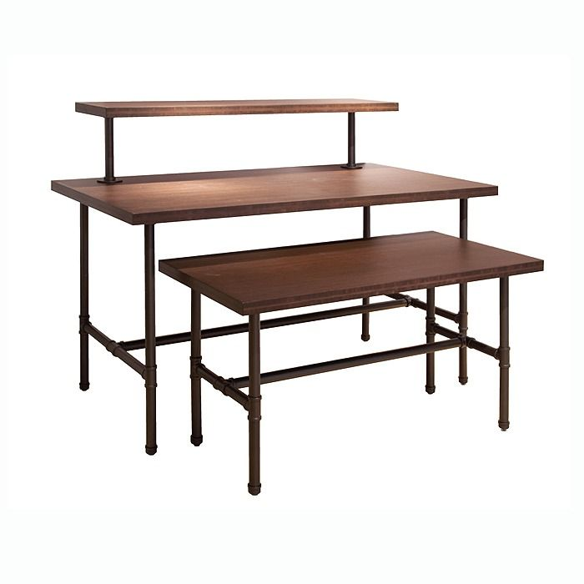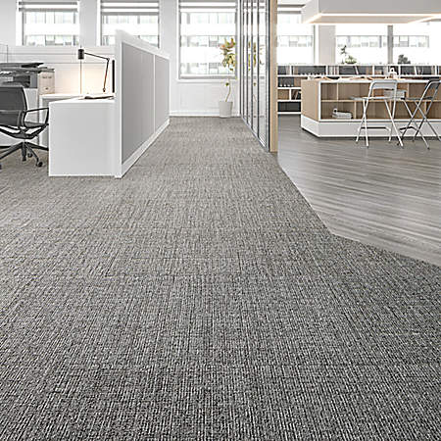**Appendix**



