Hannah Knight

Athletic Wear in the 80s vs Now

During the 80s, dress was still shifting from being dressy most of the time to more casual styles. There was more active wear and street wear seen on the everyday basis. This all started after World War II when the growth of casual sports wear led to an informality in daily life. This all continued through the 70s and into the 80s where we see a lot of denim, sneakers, and sportswear. The informality was not only in the streets, some businesses even established dress down Fridays, where denim was allowed to be worn. Some women would even wear sneakers to walk to work then change into heels upon arrival. This all continued and eventually led us to where we are today, which is an extremely casual daily life.

The 80s is when “The Fitness Craze” began. Sneakers and athletic clothes started to become an everyday item and sometimes were even seen as showing status. The people that had these new sneaker styles would be seen as upper class, as those items were very prized among society. In the 80s, sportswear was not only for working out, people wanted to wear it on an everyday basis. It was a new style for that time period, and it was starting to get very popular. Designers even started to create entire lines of sportswear because there was such a high demand for it. The items in the collections would be made out of fabric like voided velvet, which had a sheer component to it. They would also stretch knits with a lot of animal prints. Spandex was used a lot back then and was seen as perfect for working out.

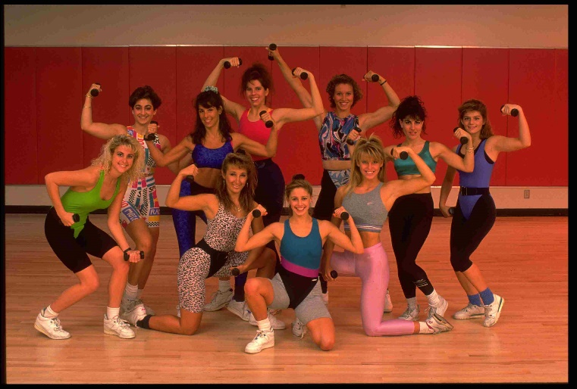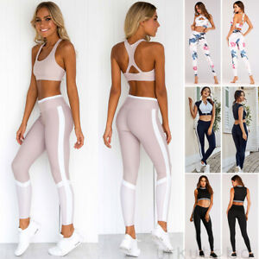

In the pictures above, you can see the one on the left is athletic wear in the 80s, and the picture on the right in current athletic wear. For the most part the garments are made out of the same materials, like knits and spandex. But as you can see the garments from the 80s have a lot of leopard print fabrics and neon colors. Today we use lighter colors that are more neutral and prints that are more subtle. Today all the athletic garments are two pieces, which usually consist of a sports bra and leggings. There are no more one pieces like pictured above.

The sneakers from the 80s you can tell are very basic sneakers. They used the same pair of sneakers for working out and for streetwear. Whereas today, many people will buy sneakers that are specifically for working out, or specifically for only streetwear. We typically do not use the same pair for all of our sneaker needs.

Overall, the athletic wear from the 80s to now has changed a lot; but there are still many aspects that remain the same. We still used most of the same fabrics to construct our clothing and it still serves the same purpose. We have just changed some details about the garments to make them more purposeful for the activities we need them for.