Hannah Knight

Article Assignment

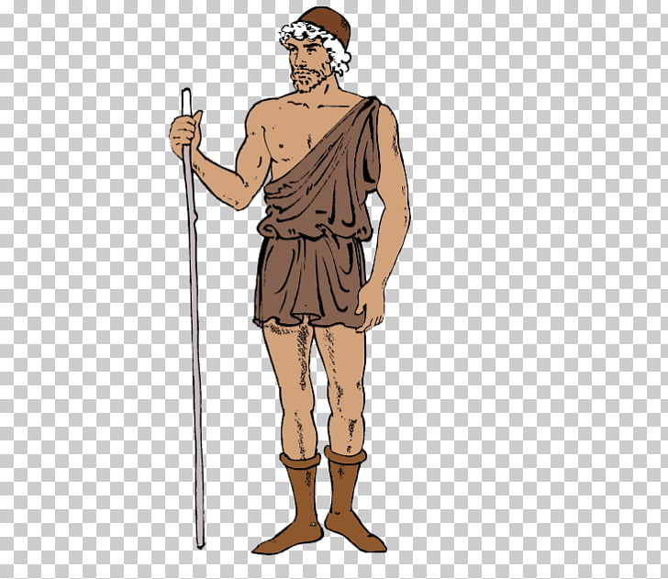 Contemporary Historic

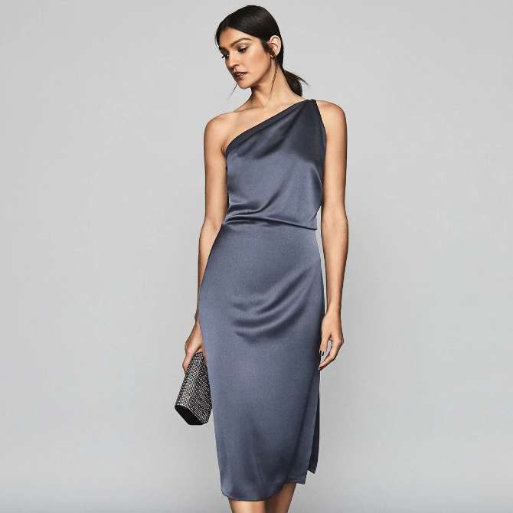

Citations:

1st image- <https://www.reiss.com/us/p/one-shoulder-satin-dress-womens-eden-in-navy-blue/>

2nd image- <https://www.uihere.com/free-cliparts/ancient-greece-archaic-greece-classical-greece-exomis-ancient-greece-7611514>

After the Dark Ages ended the Greek civilization began to evolve. Independent city states started forming and this created a democratic government. The art in Greece started to blossom too. The sculptures glorified the human body and the sculptors made masterpieces. The Greek influence was spread by Alexander the Great through the making of empires. Shortly after the death of Alexander the Great, the Greek’s power was overtaken by the Romans. Although the Romans had the power, the art and wisdom of the Greeks still shined through.

In the Greek peninsula, sheepherding was practiced because the sheep’s wool was used for weaving. Another textile the Greeks used readily was linen, especially after the 6th century BCE. Cotton was brought to Greece by Alexander the Great’s soldiers. They continued to explore the use of other textiles but wool and linen were the most used for clothing for the Greeks.

Women manufactured all the clothes for the family, including cushions and sheets. The garments that were made consisted of pleats and pinning. In this time period, fabric was not cut and sewn to fit the body. We can see this in some of the most popular garments of their time. For example, the Ionic Chiton was draped and pinned along the arm with fibulas. Another example of a popular garment in Greece was the exomis, which happens to be the article of clothing that I am comparing to the contemporary dress.

The exomis was made for the working man. It helped the men be free and able to complete all tasks without the fabric getting in the way. The exomis is a tunic, but it only has one shoulder covered to allow full freedom of the arms. The men needed to be able to move their body and most other garments in this time period would have limited their movements.

I am comparing the Greek exomis to the modern day one shoulder dress solely on looks. You can clearly see from the photographs that the purpose of this garment has completely changed. This article of clothing is no longer for the working man, instead it is used as formal wear for women. In today’s world it is seen and a very dressy piece of clothing and would never be worn for purpose of working. But that does not mean today’s designers did not use Greek influences. As you can see these two articles of clothing are nearly identical. The off the shoulder dress for women can be described as a mixture. You can see the cross-cultural influence through the shape and design of the garment; the only thing that is changed is the purpose and the fabric.

Overall, these two garments I have presented to you today are very similar yet opposites. They were made for two different purposes, but they look identical. You can see where the designers of the 21st century have been influenced by the ancient worlds, and the example I shared is just one. There are so many cross-cultural influences in designs today that we don’t even realize.