Hannah Knight

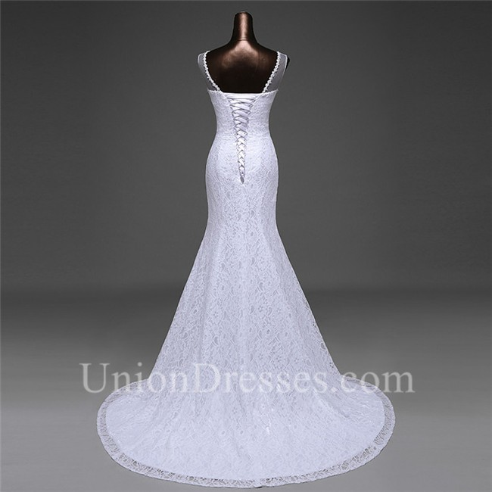18th Century

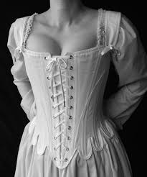Pictures: <https://www.google.com/search?q=wedding+dress+corset+back&rlz=1C1CHBF_enUS852US852&sxsrf=ALeKk023AaC3XGCaMNO3MquepF-8kyHKww:1586792954355&source=lnms&tbm=isch&sa=X&ved=2ahUKEwjfjoGz4OXoAhURXa0KHbWGCfkQ_AUoAnoECA0QBA&biw=1500&bih=858&dpr=2#imgrc=aZAgKlIGq5-xIM>

<https://www.google.com/search?q=18th+century+corset&rlz=1C1CHBF_enUS852US852&sxsrf=ALeKk00aUW960sjNCFOot4UDmiHj1RWS3w:1586792875989&source=lnms&tbm=isch&sa=X&ved=2ahUKEwj79tGN4OXoAhVJ5awKHfYVBKsQ_AUoAnoECA0QBA&biw=1500&bih=858#imgrc=CDAi-GugpsLmqM>

In the 18th century styles were reflected in the increased European trade with East Asia. They adopted styles such as the men’s dressing gowns and the mantua cut for women’s dresses. You could also see the cross-cultural influences through the types of fabric they used. Asian silk, Indian chintz, calico, and muslin fabrics were all adopted from the other countries. The Europeans started to copy these fabrics and made them into their own garments. Some of the garments worn in this century by them men consisted of underdrawers, a shirt, waistcoat, outer coat, knee-length breeches, hose, and shoes. Those things all made up the typical costume for men of this time period. For women they wore supportive undergarments, a bodice, a full hoop skirt. These styles are very prominent in these times. The women’s skirts were so big that they sometimes had to go through doorway sideways just to fit through.

When you see pictures of the garments from these time periods you should be able to tell that it was the 18th century. From the many layers that the men wore to the size of the women’s skirts there are not many other time periods that looked quite like the 18th century did. All of the garments were very intricate and tailored to the body. There was not a lot of draping going on at this point in time. The accessories also show the uniqueness of the 18th century. For men, they wore the famous three-cornered hat and the wigs with the curls and ponytail. The women would carry hand fans or a parasol, which is a type of fancy umbrella meant to block the sun. These items are all things that you would see in movies that represent this time period. It is very different than any other time in fashion.

As you can probably tell from the pictures above, I have chosen to compare the corset in the 18th century vs the modern-day corset. In the 18th century the corset made more of an appearance in day to day life. The women would either have them in the front or back of their dresses. They made the dresses look more elegant and that was just the style back then. These corsets, also called stays, were meant to be the main focus of the dress. That is very different than how we use corsets today. We do not really see corsets in women’s dress today. It is more of a special occasion type thing. Today we sometimes see them in wedding dresses in the back to tighten them up. We never see front corsets anymore. The corsets in the wedding dresses are not meant to be the main focus of the dress. They are meant to be a nice detail that also serves to tighten the dress. The corsets we see today also differ from the ones in the 17th century in style. Back then they were made with smaller strings and a decorative fabric behind to give the dress a nice pattern. Today they are typically made of thicker string so that is all you see. There is not fabric behind that is meant to be seen.

Overall, the 18th century had many garments that were very specific to that time period. From the hoop skirts to the men’s three-cornered hat you can always tell what time period they were in just by what they were wearing. They did get some influences from Asian countries and you can see that in the fabrics that they used. The 18th century was a very unique time for fashion and in my opinion one of the most interesting.